The report of Shaft Api:

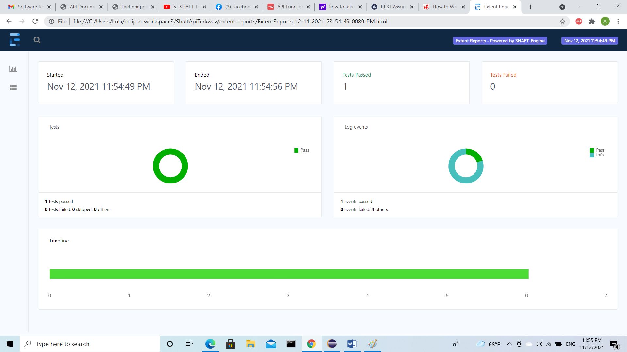

The Response body of shaft API:

{

"createdAt": "2018-01-04T01:10:54.673Z",

"deleted": false,

"__v": 0,

"_id": "591f9890d369931519ce3548",

"text": "A cat that bites you for rubbing his stomach is often biting from pleasure, not anger.",

"source": "api",

"used": false,

"type": "cat",

"user": "5a9ac18c7478810ea6c06381",

"status": {

"verified": true,

"sentCount": 1

},

"updatedAt": "2020-08-23T20:20:01.611Z"

}